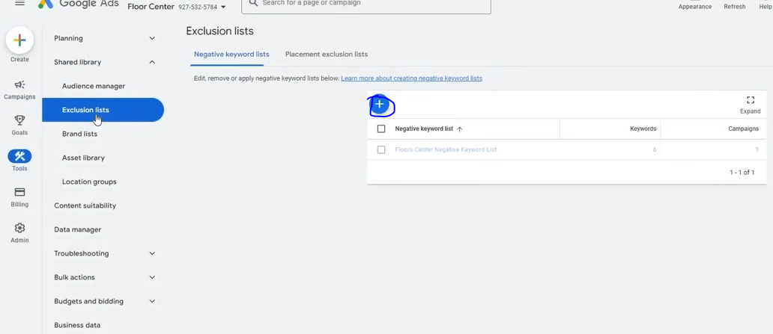
And then in sahred library go to Exclusion Tools
aand then click on + sign as marked above to create a new list
We name it negative list
We alos call exclusiun list item as negative keyword(I think so)
We want that there should be genral words that if htey come in your search term then they are irrelevant like some one is asking when where which why what these question i am asking or any other keywords as shown below

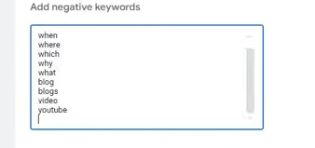
In negative keyword search match are used like phrase match , exact match , broad match
We use broad match here we add those words that are irrelevant for us like our whole keyword is not relevant
For us the who;le keyword is not relevant like
How to work on Laptop The whole keyword cannot be relevant here
Now in whatever keyword how is occuring then it will be completelyu removed
Now if ther is furthwer coming keyyword where there is how then ad will not be show to it because we have already excluded it
Now save the list by clickin on save
He is ont saving it because it is a live account
Now got o our campaign

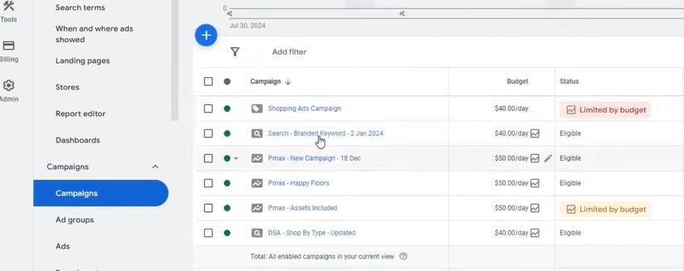

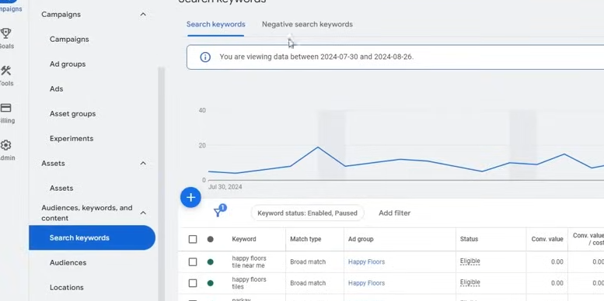

Now go to search Keywords and then to Negative Search Keywords tab

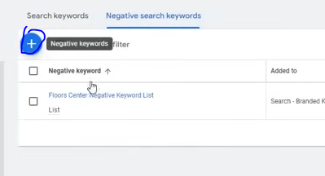
No go to + sign as marked above

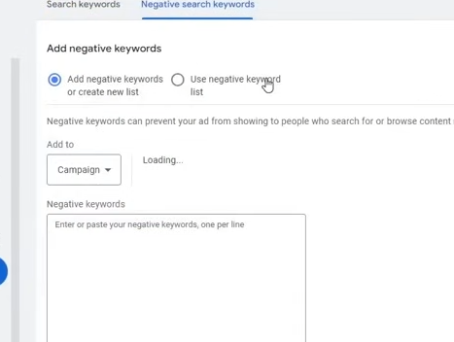
Now you need to attach your camapign to the campaignlist

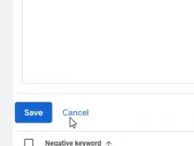
Now click on save button

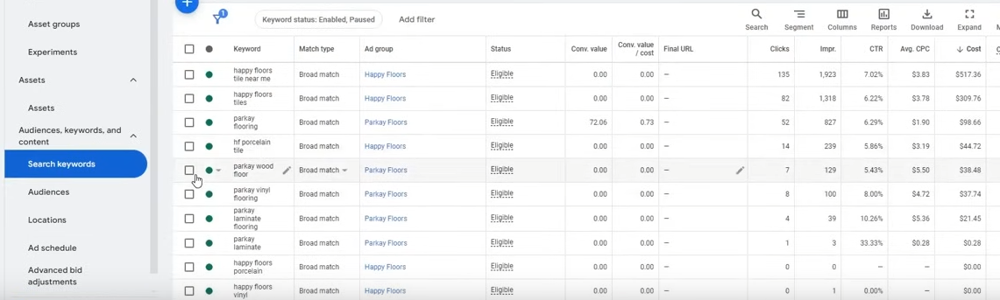
the above are the search keyword that you have given in your campaign
and another thing is search terms
which are searched by people

You will find it in Insights and reports that is search terms

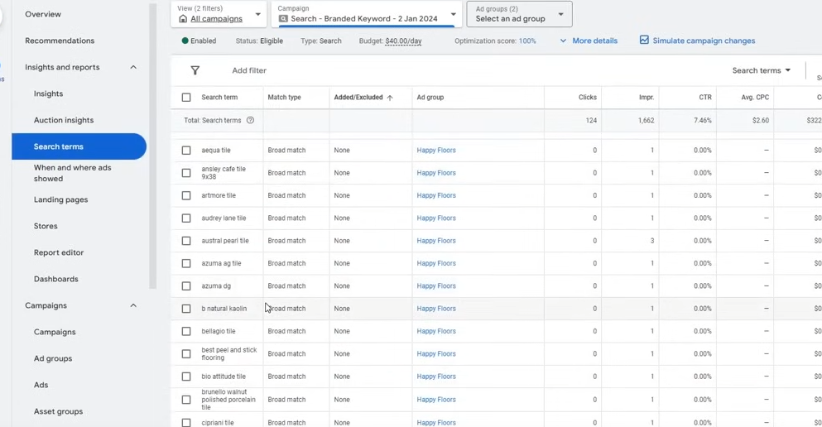
Here you see the word by searching whoich the people click on your ad
Here you need to analyze that what keywords are relevant and what are not

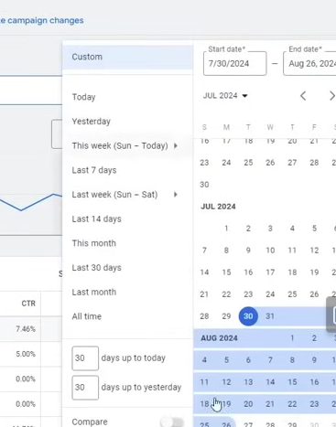
you set the date range first
Now fiultering on the basis of date you need to optimize your search terms

Now we assume that

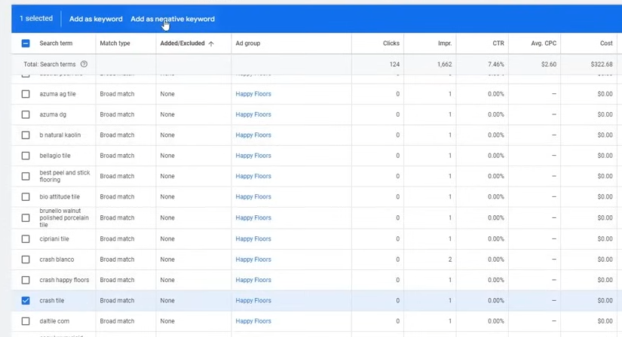
crash tile keyword is irrelevant so we select it and then click onteh add as a negative Keyword

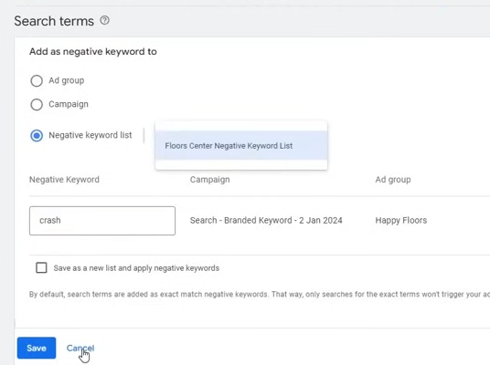
Now we choose Negative
Keyword list
and then convert the search item we chose into broader Keyword (I don't know)
and then save it no the keyword will go to our negative list and since it is connected to campgin
You can also limit it to specfic campaign or to ad group but hten you cannot shift it and it wll be restricted in that campaign and wll remain in that campaign and will not go to another campign
For that you need ot add your negative keyword to the accouint level keytword list

and is you find any relevant keyword then you can add it to the account

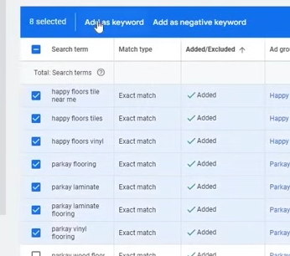

Now we select he search terms and then click on the Add as keyword as shown above
Now use tha metch type(Who knos)
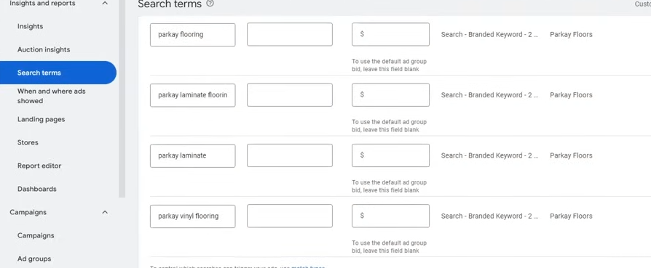
and save it

so by the keyword you are getting conversion we add it and if we remove the irrelevant keyword and make the search term to optimise it

You can optimize the search term daily or weakly
Normally we should do it after every three minutes
In starting you do it after every 1 or 2 days and then shift to every three days and when the campaign start performing better and then go to every 7 days or 4 or 5 days

Lesson 22:-
In this lesson we will learn about Google ads optimisation Part 2
Now ther are some optimsation that are done after long time for example 90 days
A campaign is working and pregressively and bringing good conversion and ou are optimising search and everything working perfectly and you don't know when to optimize it so our next optimisation date is after 90 days
Now if you have run the cmapaign for 90 days

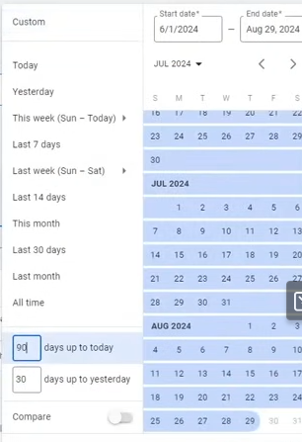
Now set the date filter such that we set it to 90 days in days upto tody field and then we apply it

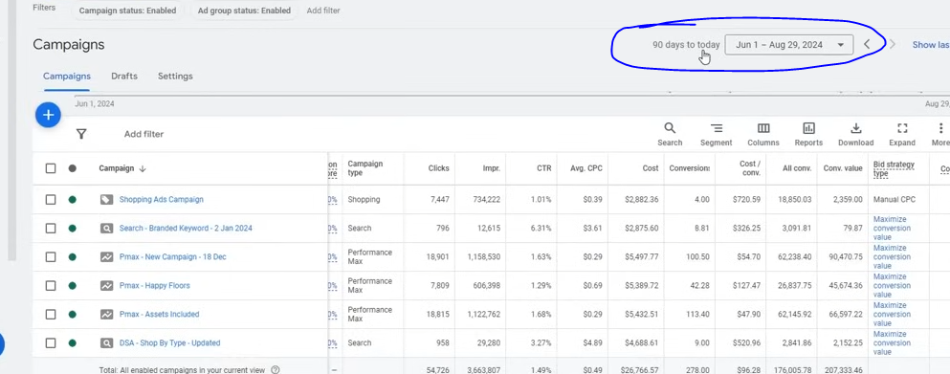
Now in above marked you can see the filter for 90 days
Phase 44
Now we do optimisation
No you need to go to the campaign

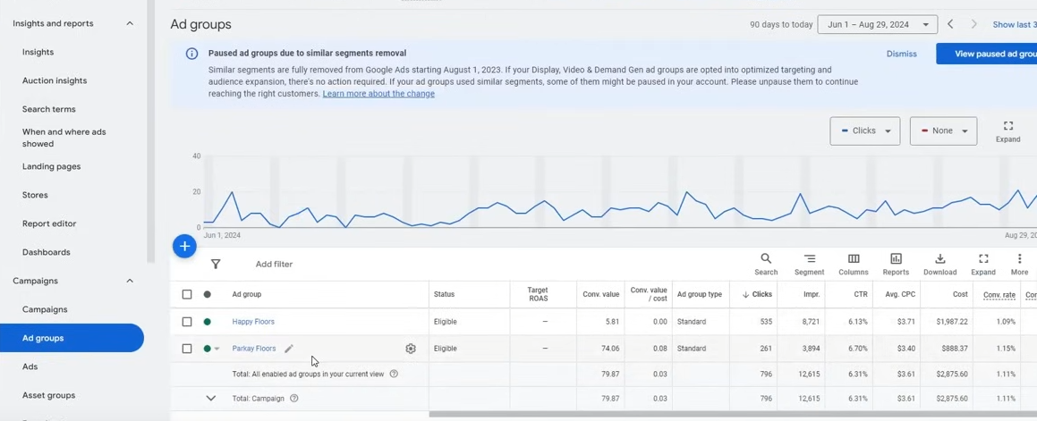
and then you need to analyze that whaat ad group is perming better
Frome above both re aompeting nobody is dominatin so we cannot take decision here
So we go to another campaign and check which ad group is performing it

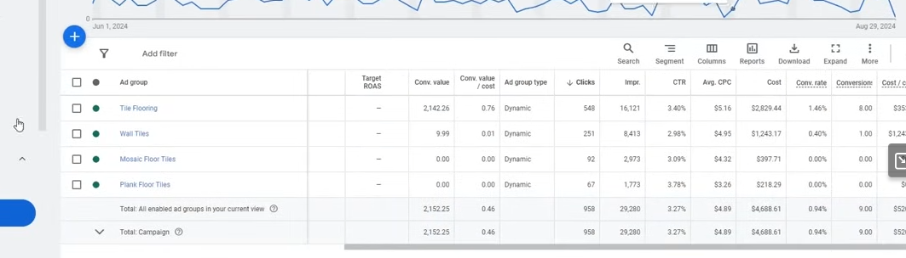
7:30:40

If i found that an ad groiup ius not performing well then we stop that ad group
If ou don't haev enough data then you don't pause it becasue if it had costed 20-30 dollars then we would have not paused it becaause it ddi not have enogh data
Note:-
In dynamic search ad there is no keyword

If a search ad group is performing better then we would have seen which keyword it is using and hten we saw wht cost was spent on it and how much total was spent and how many conversion come from there
It shuold not be like that there is only one keyword which is getting most of the convergence and other keyword are not performing well
If it is such tht then we pause the keyword that are not performing well and we will kepp that was performing
So we have seen ad group optimsation
So Now we see how to optimize keywords

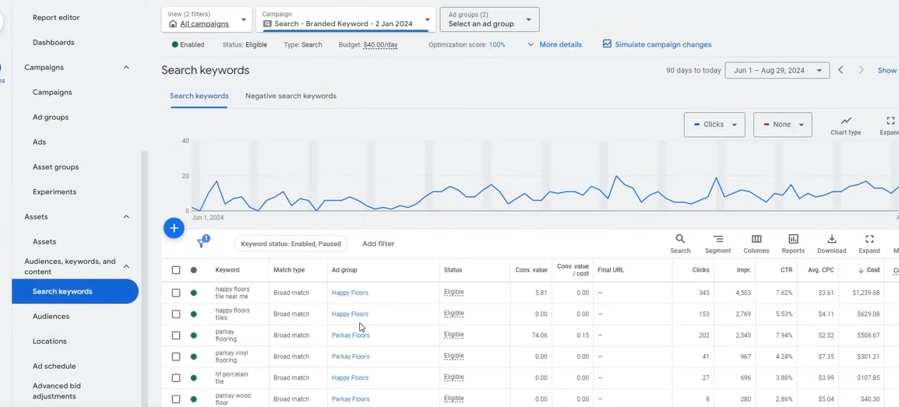
So now we go to search keywords sidemenu as shoiwn above
These are our total keyword we have
Here we see which keyword has spent most cost and its conversion is zero

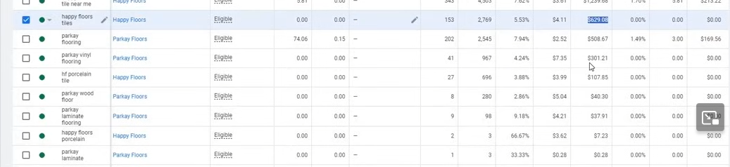
you can see tht keyword as highlighted above
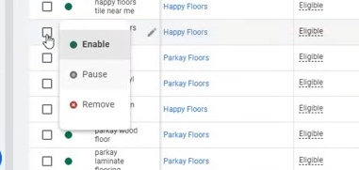
we pause it
We are not pausing it because it is a live campaign we don't want to do on it (I don't know)
These keywrods aer using budget but not giving any conversion
Now ther might be keyword which has spent low cost but zero conversion don't pause them as they don't have data in it and we can't take decision on it

Now we go to Audiences

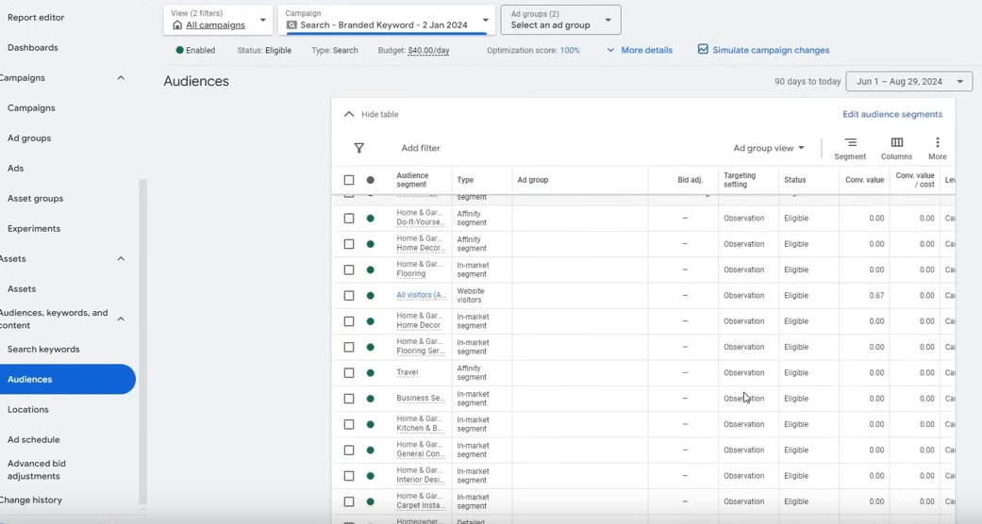
There are many audiecne which are under observatoin so we don't get anythign to change it (I don't know)
So like the keyword ad group we check here cost spent in that audience and the conversgence is 0 thenwe pause it

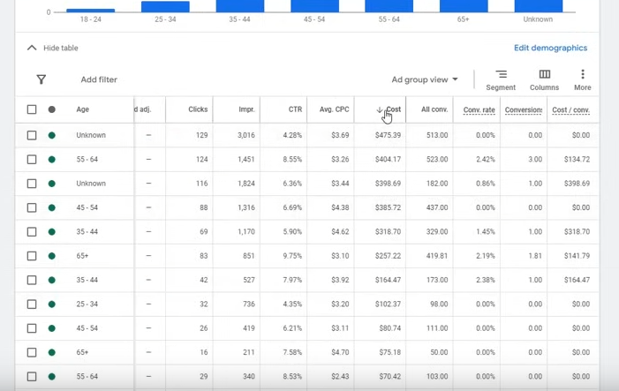
You can also do for demographics

you can optimize on the basis of gender inside demaographics and see by which gender ou get the convergence or not
Similarly for house hold income (under the demographics )
basically checking by which household i am getting convergence

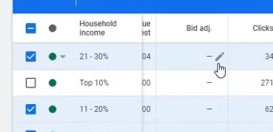
Now if any thing it is performing better let it bre ad group keyword or audience then
we edit the bid adjustment as shown above
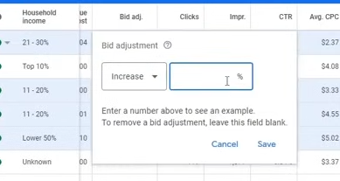
IN bid adjustment we can tell how much percentge you want to increasre the bidget tof that thing
If it is performing better we can increase it by at least 15 percent

Now we do Location optimisation

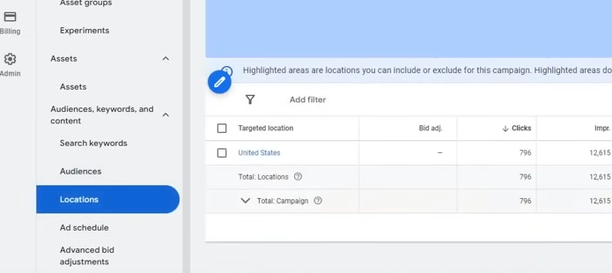
IN country us is chosen
We cannarrow our search in the chosen country by clikcing on it (in our case US)

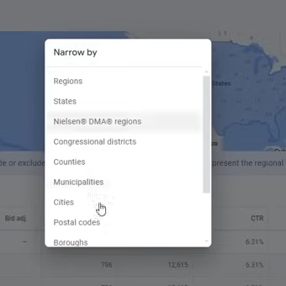
Now we go to Postal codes becasue if have chosen cities then there would have been no exact data becasue ther are many postal codes in a city

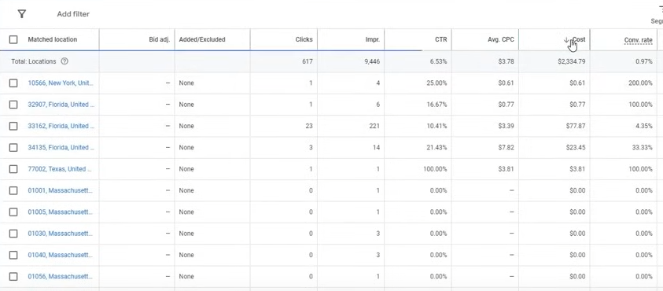
If we go to postal codes then we have exact data of that area and we can check from ehich specific area we are not getting any convergance

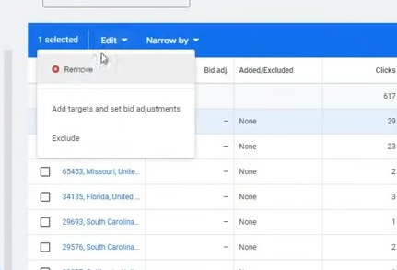
you can choose the non performing campaign and tehn clcik on edit button and then you can either remove button or Exclude it as shown above
It is recommeded to exclue it but if you could not exclude it then remove it
If see the data city wise then the data will not be accurate but by postal codes it will show data by streets then it will be more accurate

Now we see ad schedule

If you ahd already have added ad schedule then you could optimise it
I think by seeing in what time ad performs better and bring better conversion(who knows)

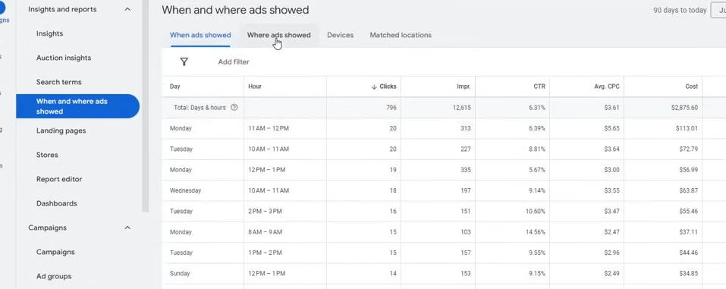
Now comes where ans when ads are shown
You can do ceratin optimisation here
like where ads showed
we could see where ad shown and from where we are getting convergence
from where you are not gettign conergence exclude that placement

Now you can go to evices and you can in which devices our ad are showing and see its performance aaccording to teh devices
If ad is performing better in a device then we increase the bid by 15 percent and idf you thignk it is nor performing beter then we decrease it by 100 percent

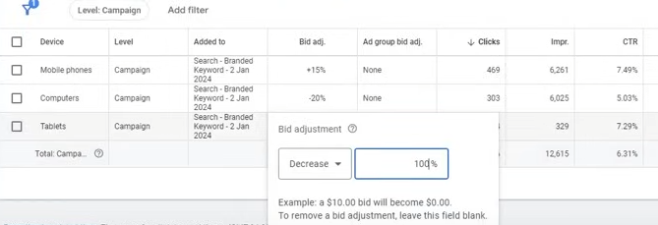
It measn 0 dollar will be spent on it
It mesns it will be excluded
If there are aompromisable result hten we decrease it by 20 percent

In when ads showed we check at what when the conversion comes and then run our ads in that time

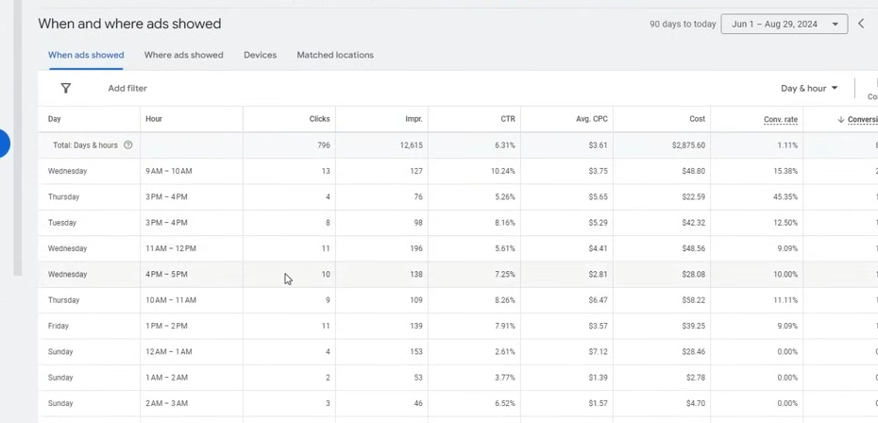
Don't overoptimize anythign
you dont't have to close anythign immediately and dont't do all teh optimisation immediately
Do it gradually then it can destroy your campaigns

Now to see our data there are filters that will not be tld by everyone

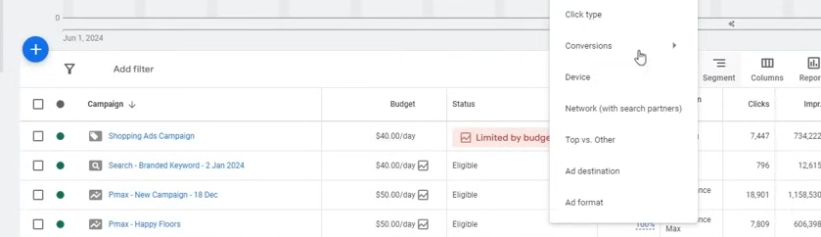
Now we go to segment adn then to convergion and then to conversion action

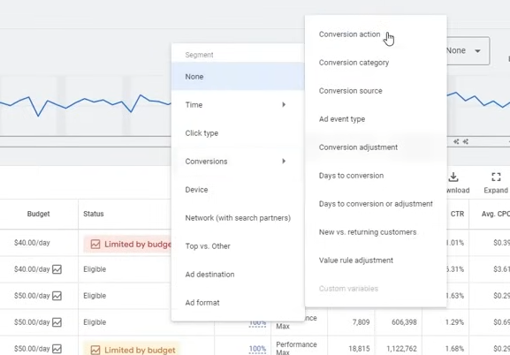
Phase 45
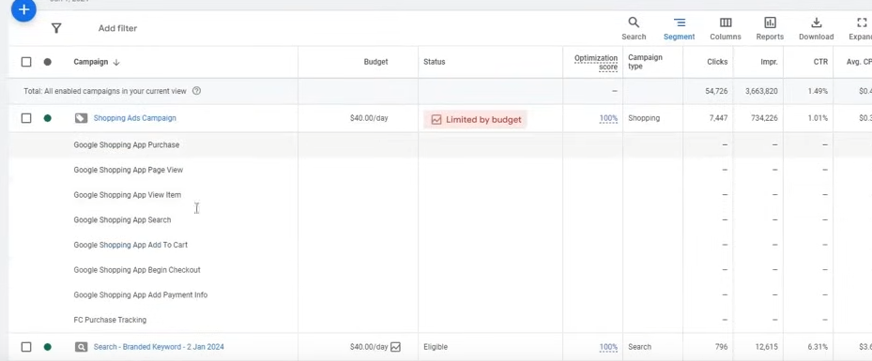
Noe you can see in which conversion tracking we are getting convergence

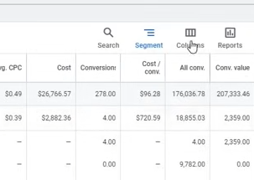
you can add your manual columns like AllColumns shown above by bclickin g on columns
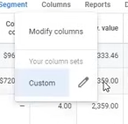
and then clcik on edit
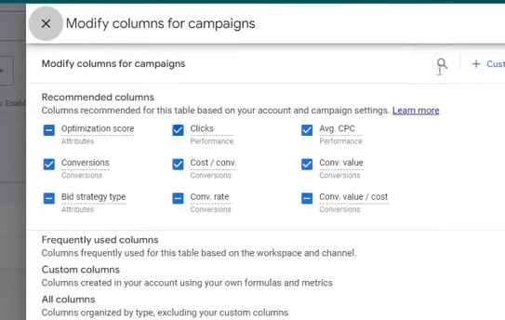
search the column you ant to add (who knows)

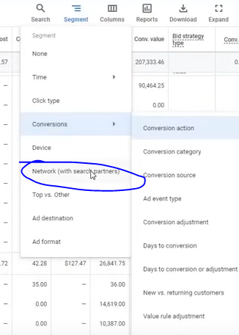
Now we can filter according to the Netwrod (search partners )

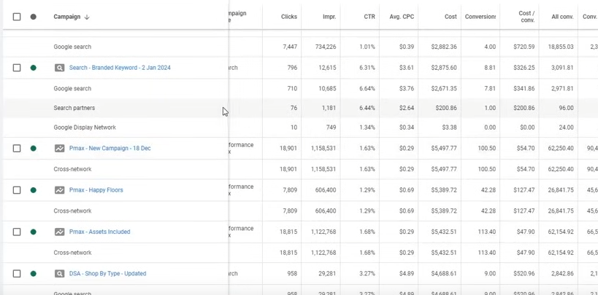
you can see reults in search partners

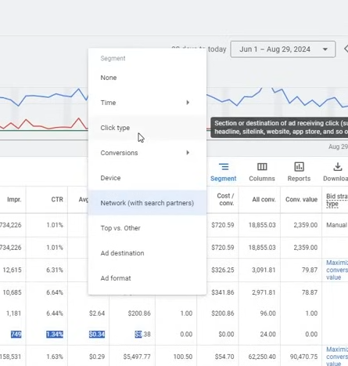
Now we click on click types (amybe filter by ctypes of click on extension)

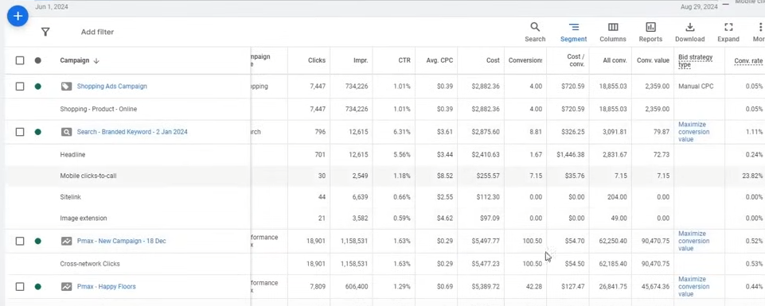
I think we see how many clicks are there in extension and when there was click on tht extension then after that did the convergence happened or not

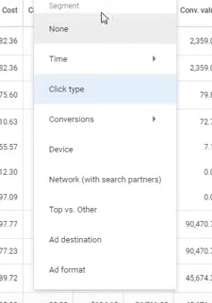
We can filter the data according to the devices on which the ads are shown
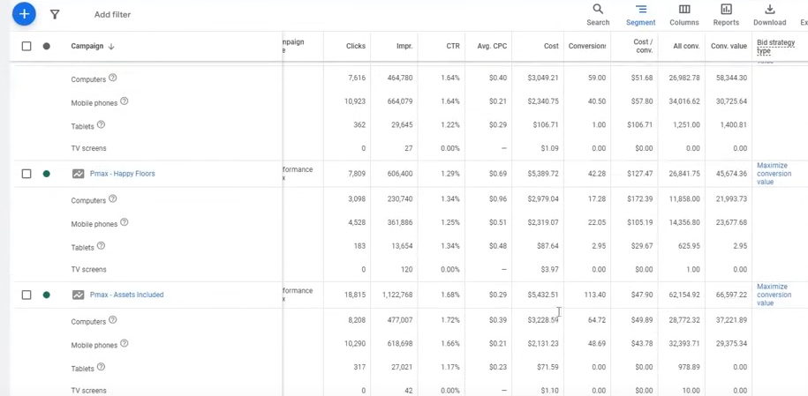
By what devices we are getting the result or not
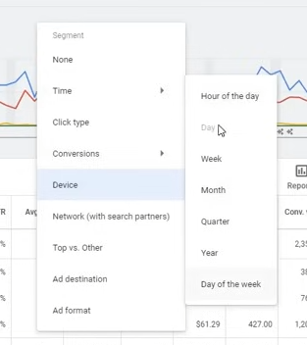
you can filer by time by going to Time and then to Hour of the day
you can see in which hour the camaign is oerforming better

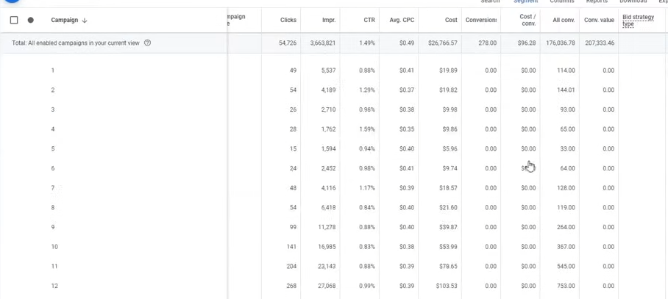
you can see it weekly , or day of the week
in wwhich day we are getting convergence and in which day we are not getting it

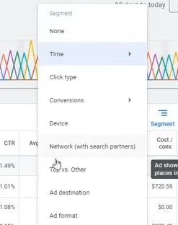
you can filter it by Top vs otheras shown above

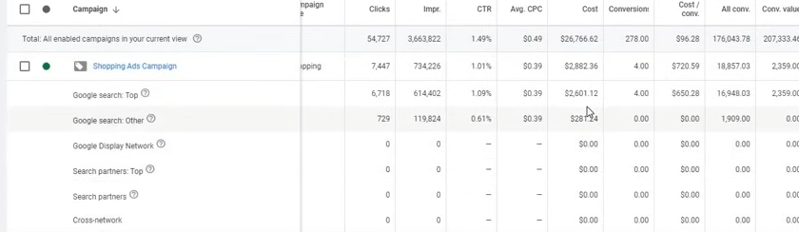
It means if your ad is shoen at the top then how much convergence you get and how much when it is present in the middle or at the bottom then what number of convergence you get
Now teacher has told us the way to monitor the data
These filters are very usefull
They will help you in taking the decision what exact the data is doing(I don't know)
you don't have to be mnisleaded you need to go the depth of the data to find that
if someone is doing exact keyword for example because of a keyword our oversall cost per convergence is seen as large
It can happen tht 20 dollar was spent on it and convergence happened on it and remaining was spent on other keyword then why to clopse that keyword By this we get influenced by wrong cost per convergence until we don't go in depth we don't know the full full data so this is our optimistion topic
So our Google ads session is completed
GoodBye

